**SIMPLE ARITHMETIC**

**LAB 3**

**SECTION X**

**SUBMITTED BY:**

**NATHAN SHULL**

**SUBMISSION DATE**

**9/22/2016**

**Problem**

The purpose of this lab is to become familiar with programming data types and operators. In the first problem, I had to first figure out what was causing unwanted outputs, and then also change the program to display the intended output. For the second problem, I had first assign all the calculations to a variable, and also figure out how to print doubles to only two decimal places.

**Analysis**

The first problem states that I must find and describe the reason for incorrect program outputs. I had to determine how to call for an integer result, and also a decimal result, depending on what the code asked for. The second problem states that I have to display the values of the given calculations without changing the syntax. I was also given the constraint of only 2 decimal places for all doubles.The third problem is attempting to figure out how the expression computed can be used in interpreting the Esplora output.

**Design**

For problem one, my first step was to find out where the errors were. In the first block of code, line 12 calls for a long floating, but an integer result is supposed to be displayed. To fix this, I simply assigned it to a decimal type instead. In the second block of code, the error occurred on line 15. Everything within printf( ) is correct, however, no variable is assigned to %d. All I did was assign the variable integerResult to %d. In the third block of code, the error existed in line 18. The code is intended to display a decimal result, and to do this, I needed to change it from a double to a long floating.

Problem 2 was a bit longer, and required more thinking. The first thing I did when approaching this problem was assigning each math problem as a variable. The variables were split between integers and doubles. I also had to spend a bit of time figuring out how to stop long floating numbers after only 2 decimals. After assigning variables, it was just a lot of repetitive code. I wrote out the all the calculations, assigned them to the correct variable, and made sure to specify that doubles are %lf and integers are %d. One other thing that I had to set up was the definition of pi.

In problem 3, I had to look at the calculations that were done in the code, and figure out how that calculation helped to interpret the data of the esplora and its magnitude. First off, the force in all 3 directions(x,y,z), was assigned to double type variables names x, y, and z. As the esplora recorded the force in each of these directions, they were put through this calculation in the code. I found that the formula for magnitude is sqrt((x^2)(y^2)(z^2)), and that’s exactly what occurred in the code. Each time the esplora recorded forces, they were ran through this code and it calculated the magnitude.

**Testing**

In order to verify that my code was in fact correct, I compiled it in Cygwin and saw the results. For problem 1, I had no problems. Everything compiled right away, and with correct results. However, for problem 2, I had many errors after my first compilation. First of all, I had not inserted any \n’s, so my entire output was on the same line. After correcting that error, I also realized that some of my doubles were not long floating, but rather decimals. I sometimes make this mistake as they both start with d and I think decimals go with doubles. After correcting those errors, I doubled checked the results of all the calculations, and they are all correct. In problem number 3, after looking at the excel graph, the magnitude of the esplora at rest was constant at one. The highest magnitude was found when I dropped it onto my lap.

**Comments**

I learned that I’m very forgetful in including newlines, and that I always need to double check my code before compiling it. I learned a lot about how to use data types and operators, and what types of data are assigned to what. Operators are very specific and picky, and you have to enter it in exactly right to yield correct results.

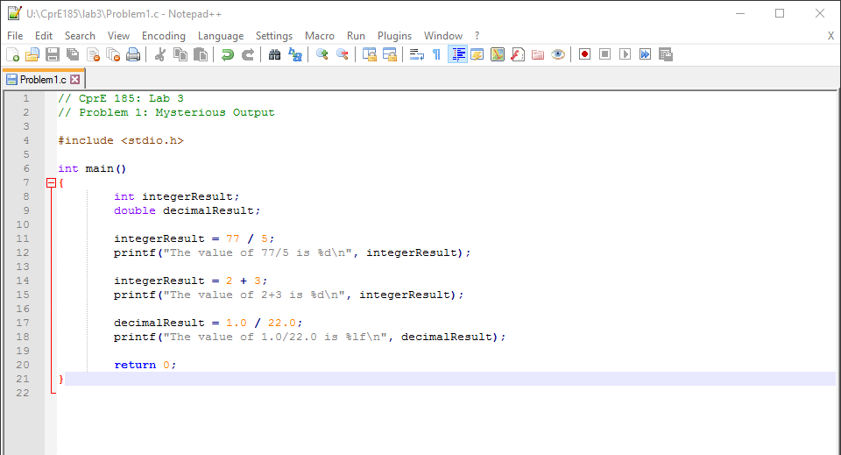

Explanation for problem 1 can be found in the design section.

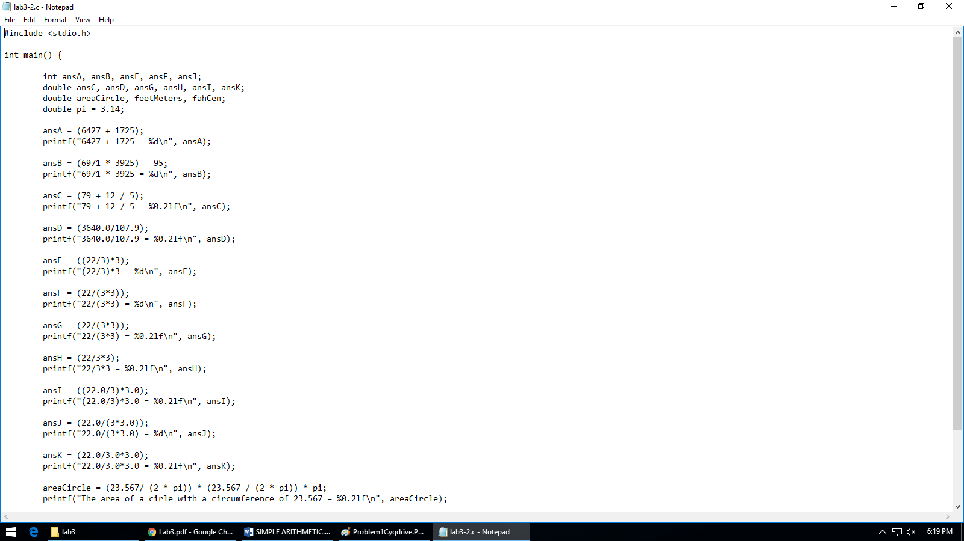

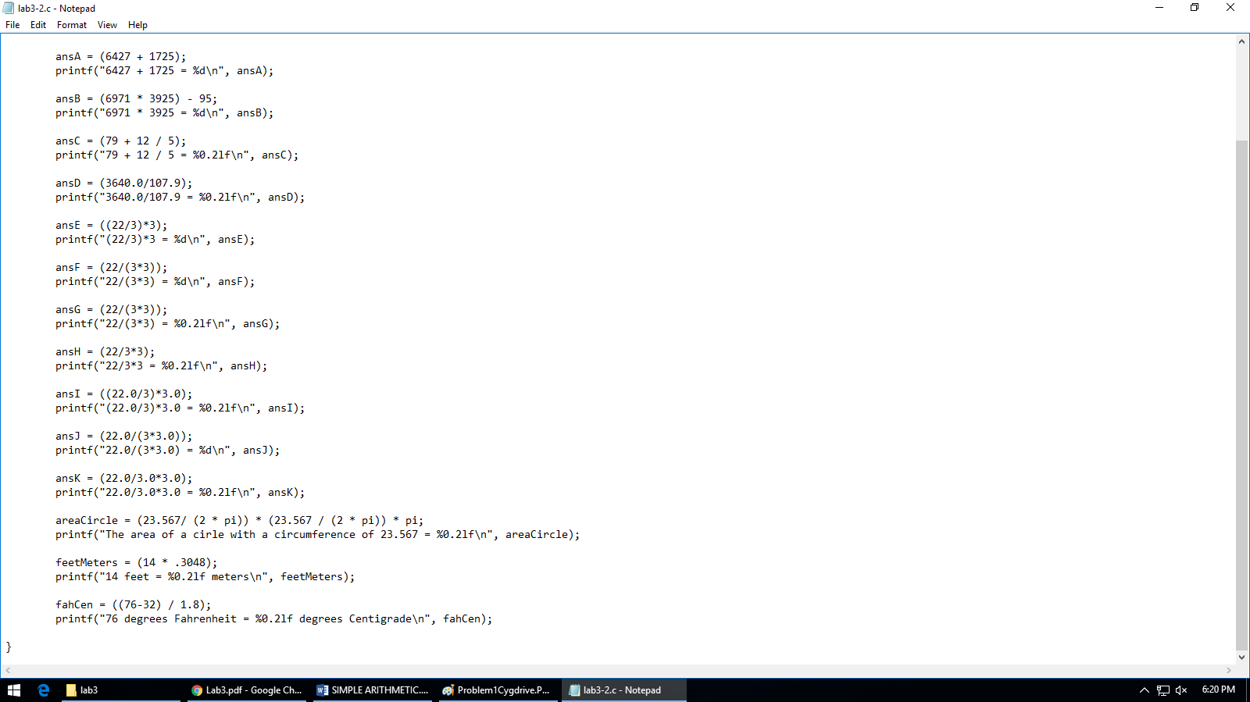

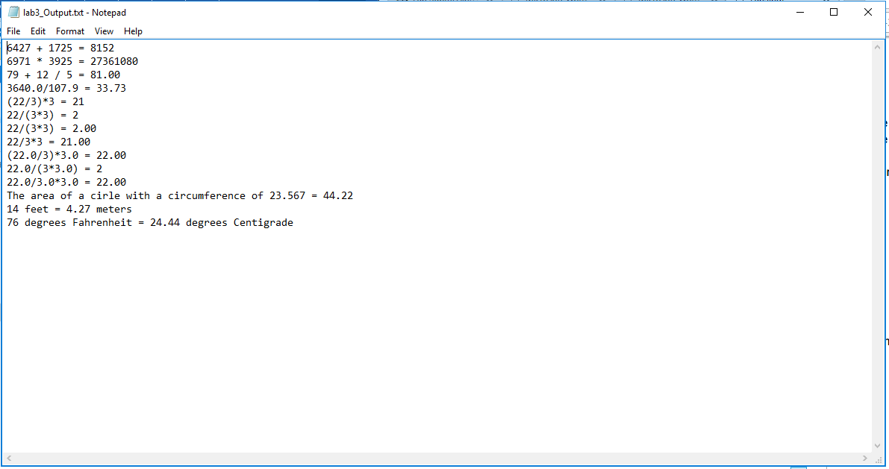

Explanation for problem 2 can be found in the design section.

